Start out with questions? Assess where the students are? Why is this important for students to learn?

- Talk about triangulation effect.
- Edu. Gov, library, Scientific Magazine
- “with two or more words in order”
- And , or and not (Boolean operaters)
- Google only uses lowercase. AltaVista and HotBot will search for unique combinations of upper and lower case. As a general rule, use lower case to broaden your search, and capitals to narrow your search. If case is crucial, enforce the punctuation by creating an exact phrase using quotation marks, "Pacific Ocean currents".

How can you distill just the right combination of keywords from all the possibilities?
- Before you begin searching create lists of keywords that describe your topic.
- Use a thesaurus to stimulate your word choice.
- Generate synonyms for the concept.
- Use search engines that provide a list of related terms along with the results of your first search.

Visual Thesaurus:
http://www.visualthesaurus.com/online/index.html

A link to make searching easier for students:

http://21cif.com/tools/locate/index.html

All the words: Volcano, at least one of the words erupt and Not using
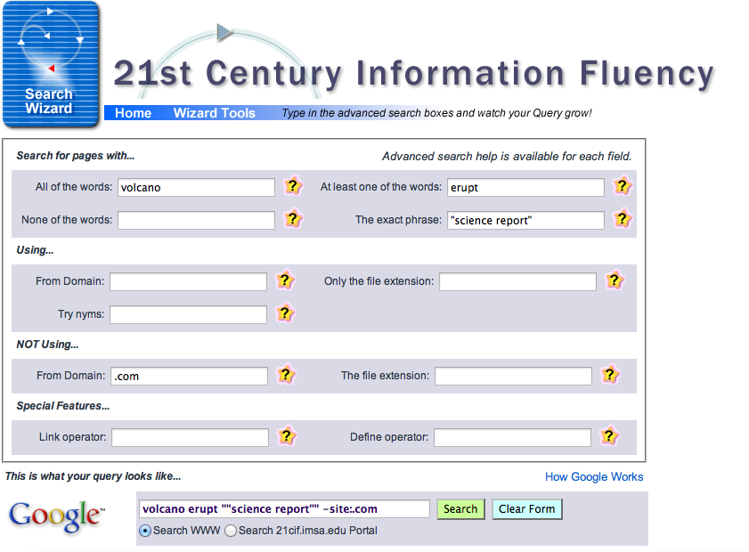(.com)

